Ulysseus European University Seed Fund Initiative for Teachers

Call for Proposals 2024
- Are you interested in collaborating internationally with another Ulysseus European University teacher?
- Would you like to drive innovation and pilot an innovative educational activity?
- Would you like to provide your students with a truly international and enriching experience without having to leave the classroom?
The Ulysseus University network invites teaching staff to create/collaborate in online learning opportunities!
Applications for the Ulysseus pilot seed fund are now open to all disciplines; proposals for Collaborative Online International Learning (COILs) or jointly developed virtual courses (Joint Virtual Course) - to be offered to students within Ulysseus - can be submitted until 15 May 2024.

Ulysseus European University Alliance Members
The Ulysseus European University. alliance comprises eight diverse universities from four European regions:
- University of Seville
- University Côte d’Azur
- University of Genova
- Technical University of Košice
- Haaga-Helia University of Applied Sciences
- University of Münster
- University of Montenegro
- MCI | The Entrepreneurial School®

Objectives
The Ulysseus seed fund is envisioned to provide financial support to innovative, co-creative and collaborative ideas in teaching and learning across the Ulysseus European University. The seed fund intends to support the development of two different types of learning opportunities/ educational offers:
- COIL (Collaborative Online International Learning): an innovative teaching methodology connecting two existing courses from different Ulysseus higher education institutions virtually. This approach brings students and teachers together across cultures to learn, discuss and collaborate as part of their regular class. The COILs are designed exclusively for students as end users. By connecting the classrooms located in different countries, the students and teachers profit from a transnational educational experience. The courses should be an integral part of the curriculum and involve the participation of at least two teachers from these institutions.
- Ulysseus Virtual Joint Courses: a newly created course by a minimum of two teachers from two Ulysseus universities. Open to students from all eight Ulysseus partner universities on the Ulysseus Learning Platform, MOODLE. The priority topics for these virtual courses are already defined in the Ulysseus project proposal. Additionally, proposals for creating additional joint virtual courses related to the Ulysseus innovation hub activities of partner universities as well as transversal topics supporting the Ulysseus Mission can be submitted through this call.

COILs
Basic elements of Ulysseus Collaborative Online International Learning are:
- Collaboration between teachers from two (or more) Ulysseus partner universities in any discipline: Teachers collaborate with colleagues at the partner university within their own, thematically similar course and bring their students together online in a virtual space. Also, interdisciplinary settings are welcome.
- Virtual Learning activities, where students jointly work on a task, case or project in internationally mixed teams as part of their studies at their local institution. The COIL should be an integral part of the curriculum/part of an existing class.
- Effective COIL collaborations take place over several weeks (modules) or ideally throughout the entire course/semester to foster meaningful and qualitative intercultural online collaboration among students.
- Students are graded and receive credits for the course at their own home university.
- The COIL model provides a well-defined and innovative methodology for creating international opportunities for all our students without them having to leave the classroom.
Please find more information regarding COILS via this link.
The COILs awarded with a seed funding grant must be implemented by the end of July 2025.

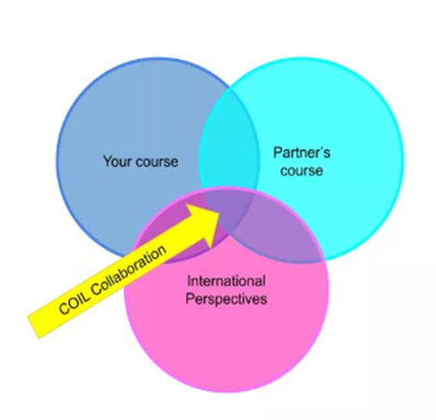
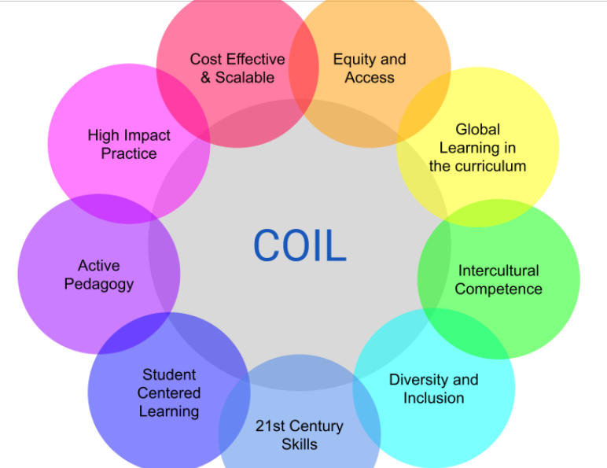

Figure 1 Figure 2

Online-Info-Session on COILs
The Ulysseus Alliance will support teachers by offering online information sessions for interested teachers on how to plan and implement a COIL. The first information session is scheduled for 23 April. More details are provided below:

SIGN UP for COIL Information Session:
Are you excited to explore Collaborative Online International Learning (COIL) further? Interested in exploring its benefits, challenges, and where to start? Make sure to join our Information Session!
Date: Tuesday, 23 April 2024
Time: 12:00-13:00 o’ clock
Topic: Breaking borders: A journey into Collaborative Online International Learning (COIL)
Target Audience: teachers/lecturers interested in organizing a COIL
Please register via this link

Ulysseus Virtual Joint Courses

Ulysseus Joint Course means that at least two Ulysseus partners are involved in co-creation of the course and/or implementation of the course.

Six course topics have already been defined within Ulysseus. For each of these course topics the coordinating university has already been predefined (see list below). In addition to the coordinating university, the application form requires at least one other academic from another Ulysseus university, who is involved in the course creation and/or implementation.

The Joint Virtual Courses are:

- Course Basics of project management (University Côte d’Azur + Ulysseus Partner)
- Course Future leadership skills (MCI | The Entrepreneurial School® + Ulysseus Partner)
- Course Academic Integrity (University of Montenegro + Ulysseus Partner)
- MOOC Design Thinking (Haaga-Helia University of Applied Sciences + Ulysseus Partner)
- Microcredential Digital Skills (University Côte d’Azur+ Ulysseus Partner)
- Course Innovation Skills (University of Münster + Ulysseus Partner)

The above-mentioned courses should be ready for evaluation at the latest in October 2024. The course should be implemented by the end of 2025.

If teachers are interested in proposing a new course not on the list above, the content should enhance the innovation hub activities or other objectives of the Ulysseus educational offer.

Partner search
Before applying for this seed funding call, it is necessary for teachers to have already reached an agreement with their respective colleague/s from Ulysseus partner universities regarding the COIL/Joint Virtual Course plan. For those interested in collaboration but unsure whom to partner with, they can reach out to their Ulysseus Local Mobility Officers via ulysseusmobility@ucg.ac.me. The Local Mobility Officer can assist in facilitating matchmaking opportunities. We also highly encourage you to connect to the Ulysseus Linkedin page.

Funding and Financial Procedures
This seed funding will facilitate the co-creation among academics to prepare joint educational offers. With the support of the seed funding, the teachers are able to meet physically to jointly design and plan the COIL/ Virtual Joint Course.
- The seed fund covers for the applicant: travel, accommodation, daily allowance, other eligible costs (max. 2500 €).
- The funds will be paid out to the applicant (= travelling teacher) by his/her/their Ulysseus home university.
- The funds will be paid out by the Ulysseus partner of the respective applicant.
- The funds cannot be paid out as a salary or teaching load.
- Expenditures will be reimbursed on real cost incurred based on supporting documents (i.e. invoices, travel tickets).
- Travel costs incurred must be compliant with the local university´s travel policy and regulations and economically justifiable.
- Proof of delivery: after the activities incurred, a report of the expenditures, meetings/activities and attendance sheets (in case of travel) signed by the participants.
- Should the outcome (COIL/ Virtual Joint Course) not be delivered as agreed, the eight Ulysseus higher education institutions reserve the right to demand repayment of the expenditures incurred or disbursed by the applicant.

Eligibility and Evaluation Criteria

Seed funding projects must involve:

At least two lecturers from two different Ulysseus partner universities.

Selection criteria:
- Expected added value for teaching and learning in Ulysseus (benefitting students/staff)
- Relevance of academic expertise on the topic
- Clearly formulated budget and goals
- Realistic work plan with clear deliverables (COIL or Joint Virtual Course)

Grant Information and Timeline

Eligible applicants | Teachers and Lecturers of the 8 Ulysseus partner universities
Expected Output | - COILs (Collaborative Online International Learning)  - Ulysseus Joint Virtual Course
Language of instruction | English (as lingua franca)
Seed fund of accepted proposal in this call (traveling costs, accommodation, daily allowance, other eligible costs) | Max. 2500€ per applicant
Deadline for proposals: | 15 May 2024 (23:59 CET)
Announcement of results: | Mid-June 2024
Funding period for this call: | Expenses must be claimed by the following deadlines:  - The COILS must be implemented by the end of July 2025.  - For Joint Virtual Courses the travel needs to take place before 15 October 2024. (The courses should be ready for evaluation at the latest in October 2024. The Joint Virtual Courses must be implemented by the end of 2025).
Link to Application Form | Link

Application Procedure
- Applications can be submitted until 15 May 2024 (23:59 CET), via link.
- The call is open to teaching staff.
- Applications should be submitted by the traveling partner only.
- Applicants should already know the contact persons in the partner university with whom they will be developing the COIL/Joint Virtual Course.
- The selection process consists of two phases: First, the evaluation of applications will be conducted internally in the partner universities creating a shortlist. The final selection from the shortlists will be made by the Ulysseus Joint Education Committee with representatives from all eight Ulysseus partner universities.
- Proposals should be submitted in English.

When submitting your application, you will be requested to include the following:
  - Course abstract, should include course description and work plan (max. 500 words),
  - The budget allocation,
  - Letter of support issued by the host university from the Head of Department.

Additional Information and Contact Details
- About Ulysseus
- COILS
- Ulysseus Linkedin page

